Use Case Component 2- TWEET APP

Tweet App is SPA (Single Page App) for registered users to post new tweets, reply to tweets, like/unlike tweets.

User Landing Page:

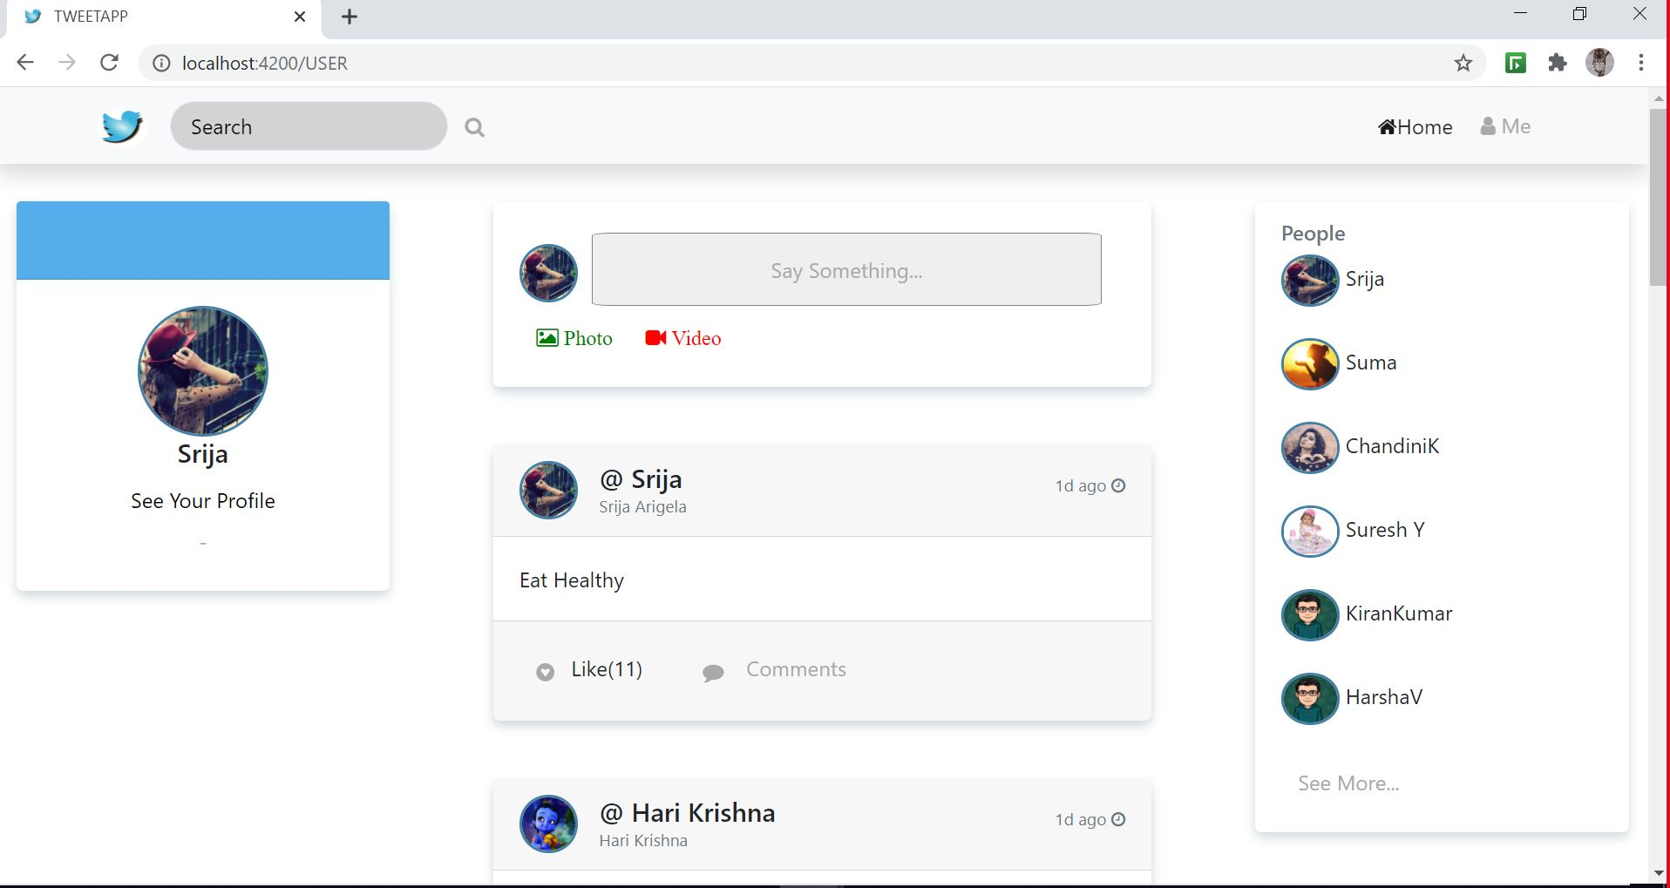

The core Modules of the tweet App are:

1. User registration and login

Register:

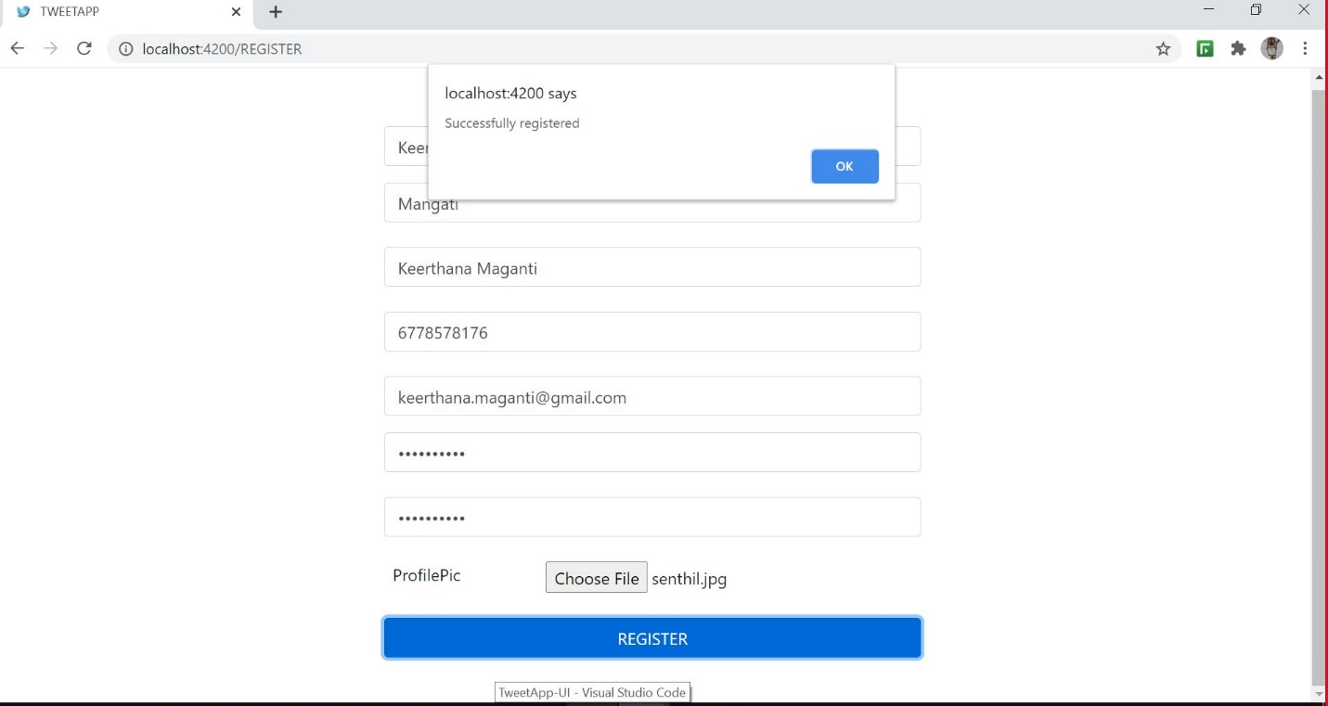

Login:

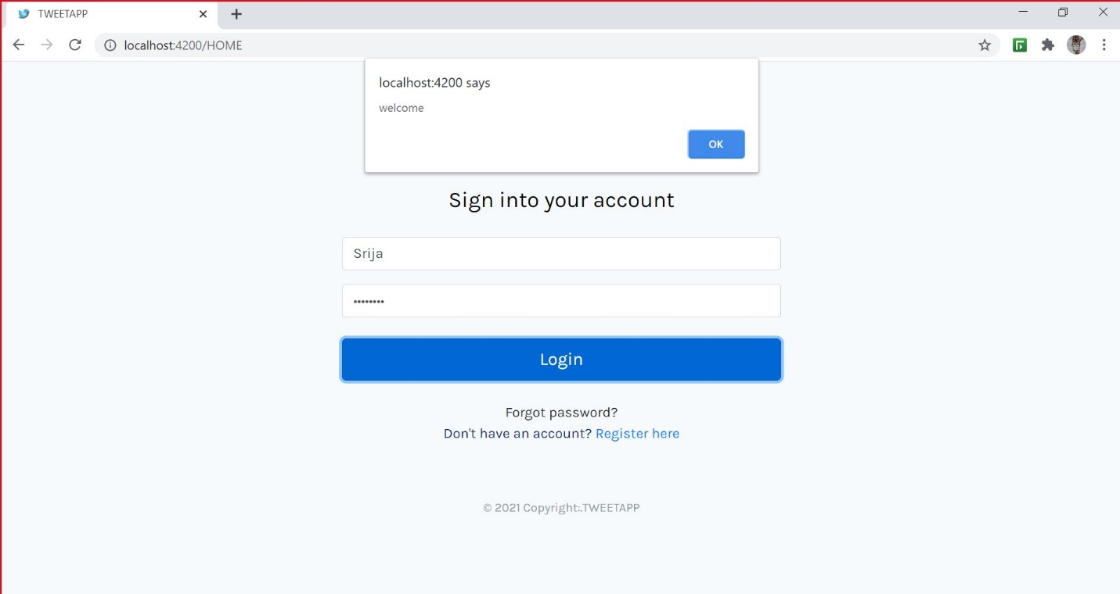

1. Post tweet

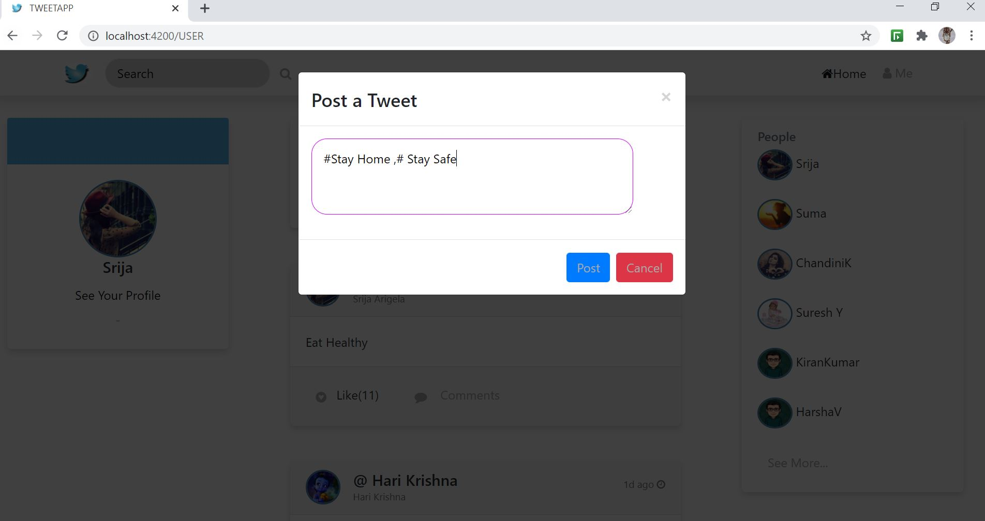

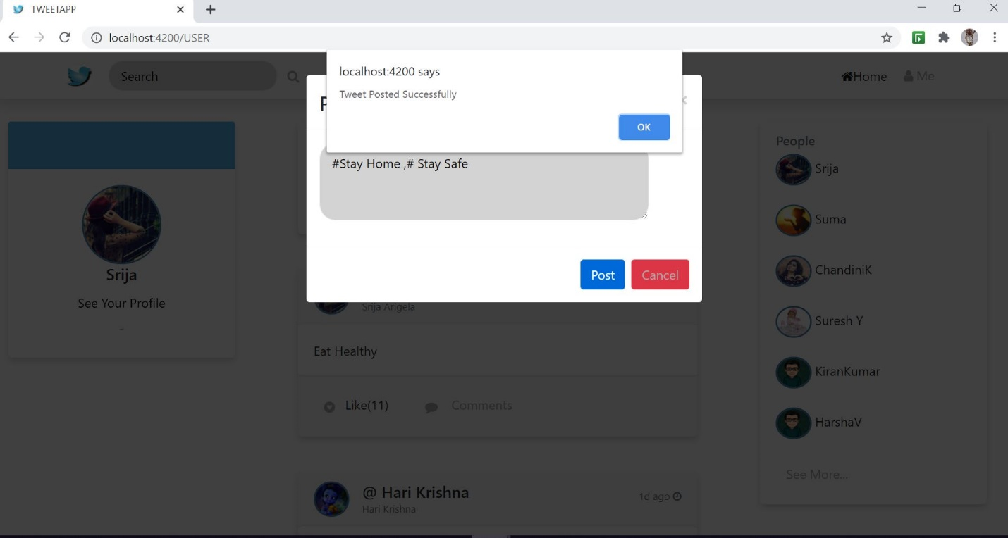

1. View users/handles and their respective tweets
2. Tweet Component Sketch

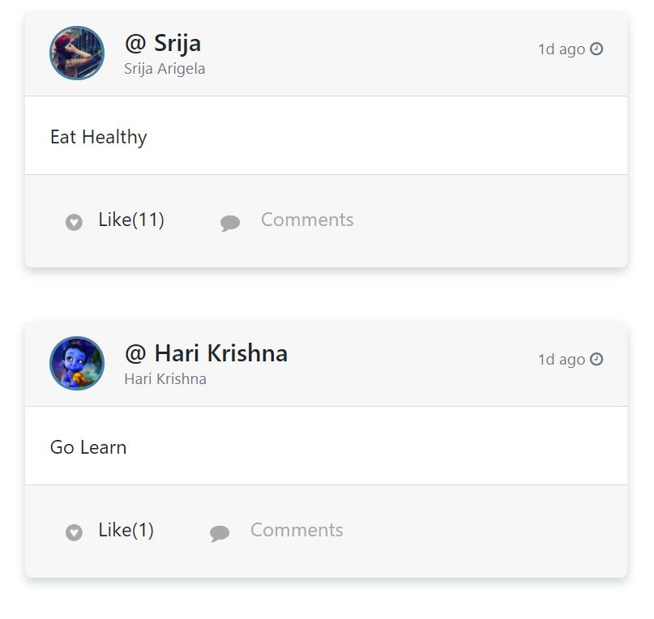

1. Users and Their tweets

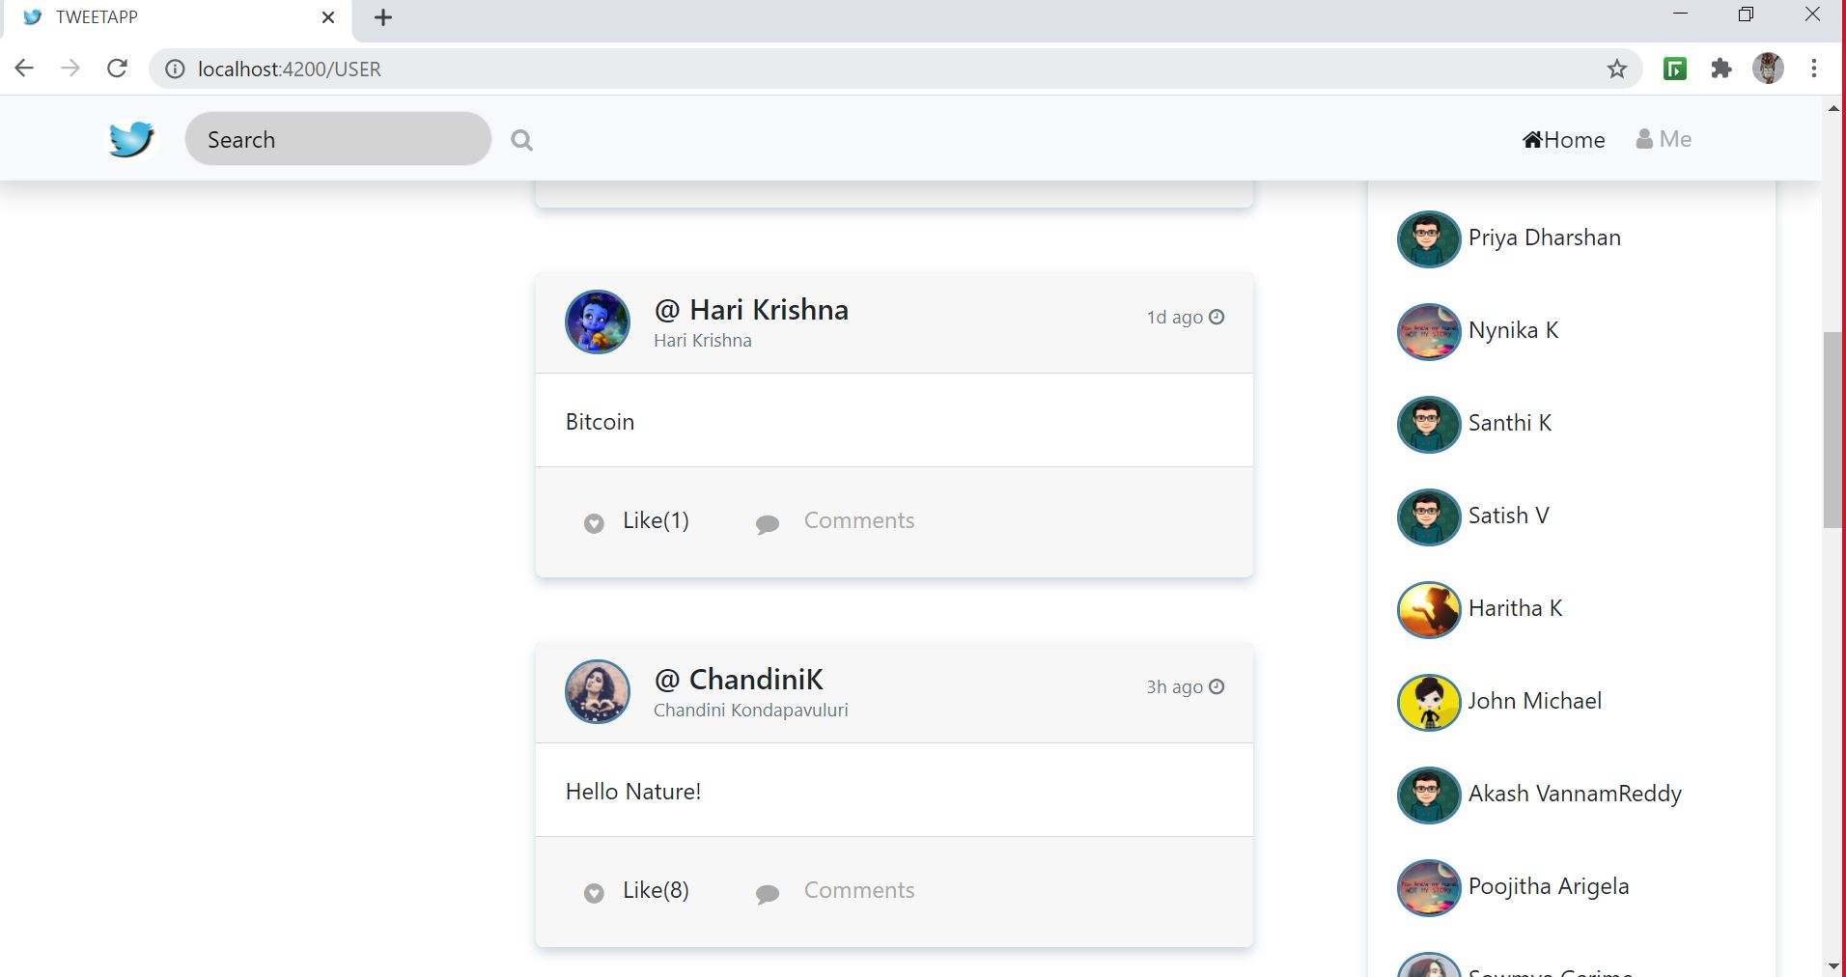

**FYI :** https://github.com/Srija47/UseCaseComponent2-TweetApp